Business Question and Visualization Report
Name | Manpreet Kaur
Date | 17 July 2026
Project Name | Food Ordering Behaviour and Consumer Trends: A Structured Analysis of Choices and Habits

Business Questions and Visualization
The process involves defining specific business questions to guide the creation of meaningful and actionable visualizations in Tableau. Well-framed questions help in identifying key metrics, selecting relevant data, and building visualization that provide insights.
Q1. Which cities generate the highest order value?
- Visualization: Bar chart (Top N filter) showing order value by city, ranked and limited to top 3.
- Insight Provided: Mumbai generates the highest order value at ₹4,640,319, followed closely by Pune (₹4,616,213) and Bangalore (₹4,539,656). The narrow gap between the top 3 cities (~₹100K) indicates strong, evenly distributed demand across major metros rather than a single dominant market — useful for prioritizing delivery fleet allocation and city-specific marketing budgets without over-indexing on one location.
- Screenshot of visualization:
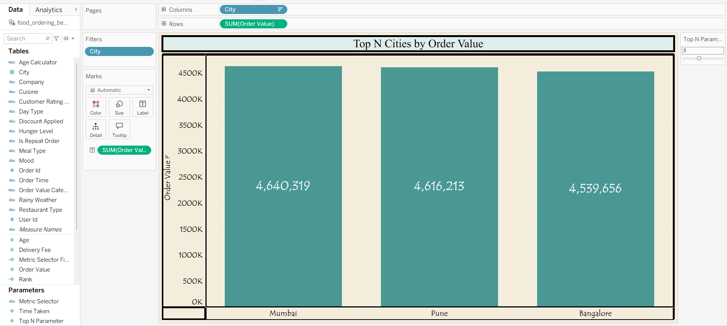
Q2. How does order value vary across different cuisines?
- Visualization: Lollipop chart (bar + circle marks) showing sum of order value by cuisine type.
- Insight Provided: Desserts led with ₹4,627,202 in order value, followed by Fast Food (₹4,592,774) and South Indian (₹4,582,780), while North Indian trails at ₹4,466,788. This indicates indulgence/treat categories (desserts, fast food) may have higher price points or larger basket sizes than staple meal categories — useful for promoting higher-margin cuisines through bundling or upselling.
- Screenshot of visualization:
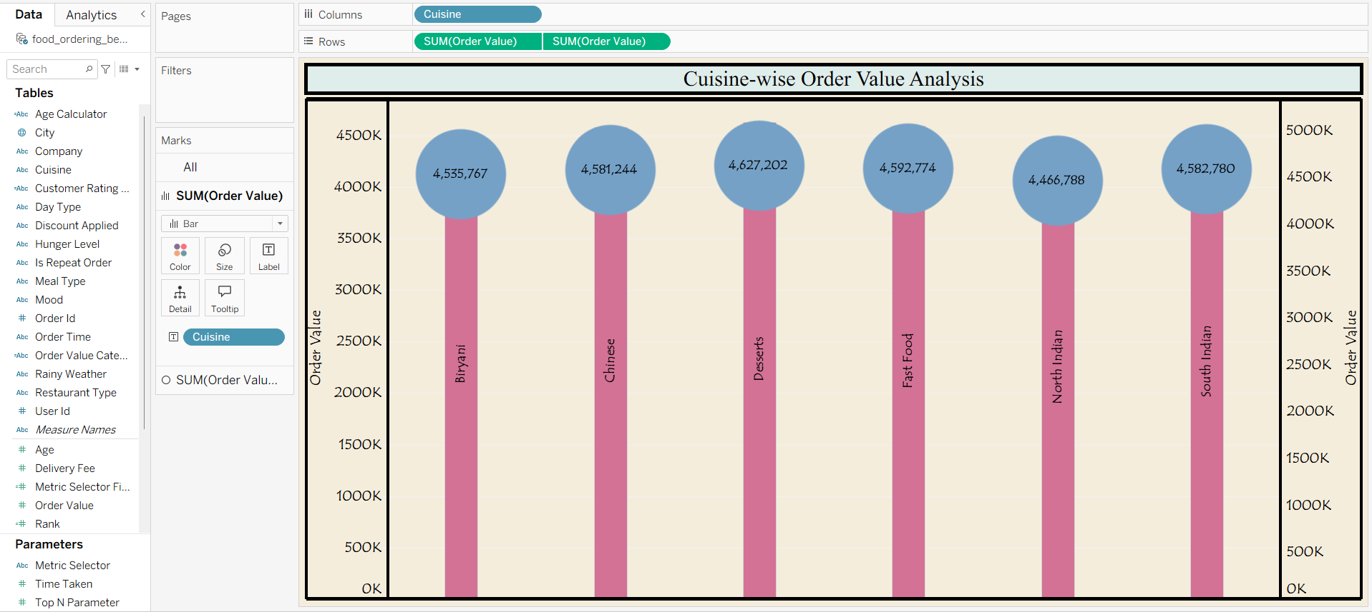

Q3. How is order value segmented across meal types and spend categories?
- Visualization: Stacked bar chart showing sum of order value by meal type, broken down by order value category (High, Low, Medium, Premium).
- Insight Provided: Spend tiers are distributed fairly evenly across all four meal types, meaning no single meal occasion (e.g., dinner) disproportionately drives premium spending. This flags an opportunity to design targeted premium offers for breakfast/snacks, which are traditionally lower-spend occasions but show similar tier distribution here.
- Screenshot of visualization:
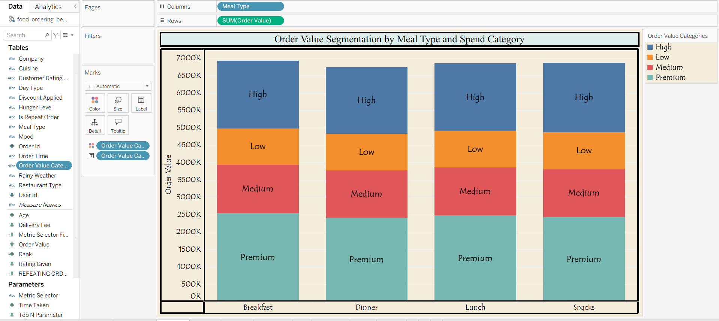

Q4. How do customer satisfaction ratings vary by cuisine and rating band?
- Visualization: Heat map (tree map style) showing average customer rating by cuisine type, colored and grouped by rating category (Excellent, Average, Good, Poor Service).
- Insight Provided: Chinese (9.448) and South Indian (9.546) cuisines show the highest satisfaction on the top-tier metric, while other metric groupings for the same cuisines range lower (as low as 2.9–3.0). This suggests satisfaction is highly dependent on which service dimension is measured (e.g., taste vs. delivery experience vs. packaging), pointing to a need for cuisine-specific quality improvements rather than a blanket strategy.
- Screenshot of visualization:
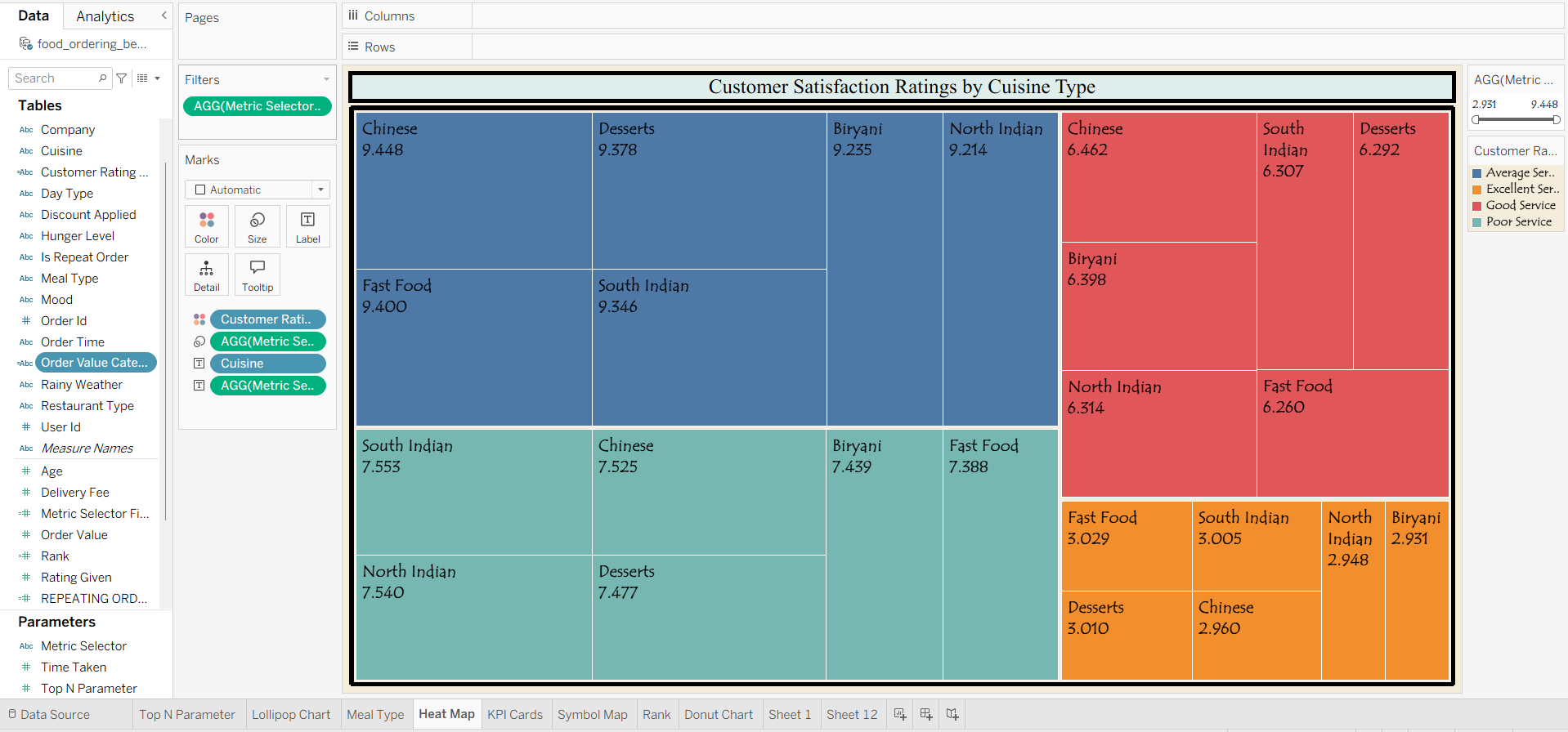
Q5. What do the key operational metrics look like at a glance?
- Visualization: KPI cards summarizing core aggregate metrics.
- Insight Provided: The dataset covers 50,000 food ordering transactions, with an average customer age of 31, an average delivery fee of ₹60, a total order value of ₹27,386,555, an average customer rating of 3, and an average order time of 7 minutes. These KPIs give a quick operational health check — the moderate average rating (3) alongside strong overall revenue suggests satisfaction has room to improve without currently limiting order volume.
- Screenshot of visualization:
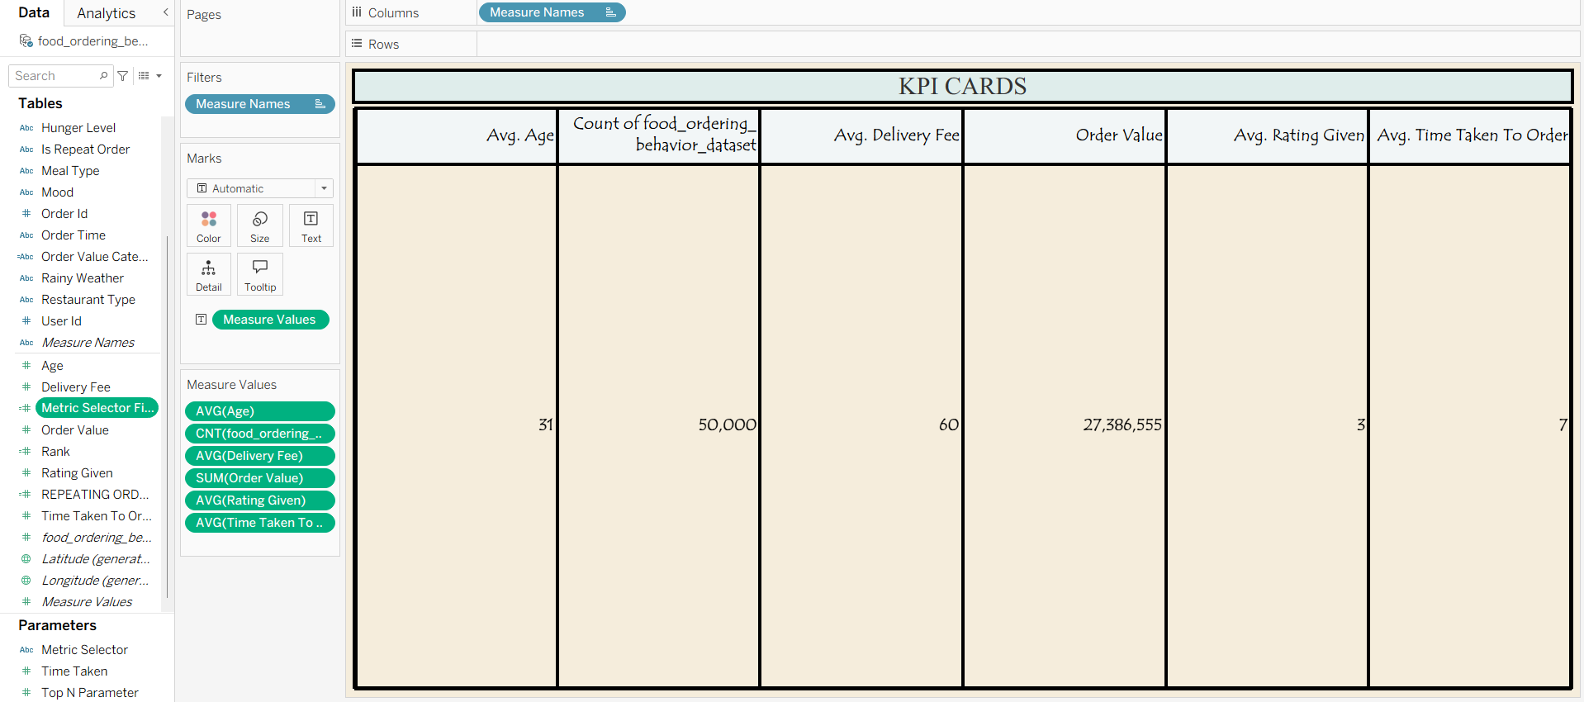

Q6. How is order value geographically distributed across cities?
- Visualization: Map (symbol map) showing sum of order value by city location.
- Insight Provided: Order value is concentrated in western and southern India — Mumbai, Pune, and Bangalore show the largest bubbles — while Chandigarh in the north shows the smallest. The geographic clustering suggests demand is stronger in metro hubs along the west/south corridor, useful for prioritizing regional delivery infrastructure and marketing spend.
- Screenshot of visualization:
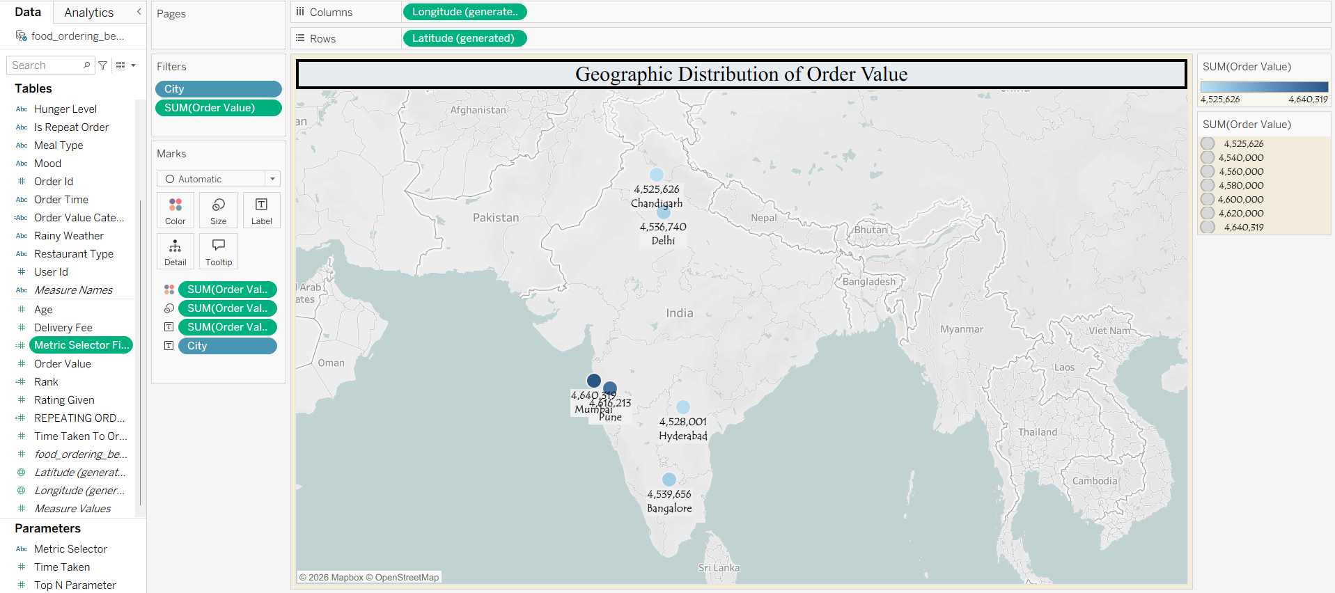

Q7. How do cities rank comparatively on total order value?
- Visualization: Ranked table showing city, rank, and total order value.
- Insight Provided: Mumbai ranks 1st (₹4,640,319) and Chandigarh ranks last at 6th (₹4,525,626). The gap between adjacent ranks is small (often under ₹15K), meaning small operational improvements — like reduced delivery time or targeted offers — could shift a city's rank position, making this table useful for setting realistic short-term city-level growth targets.
- Screenshot of visualization:
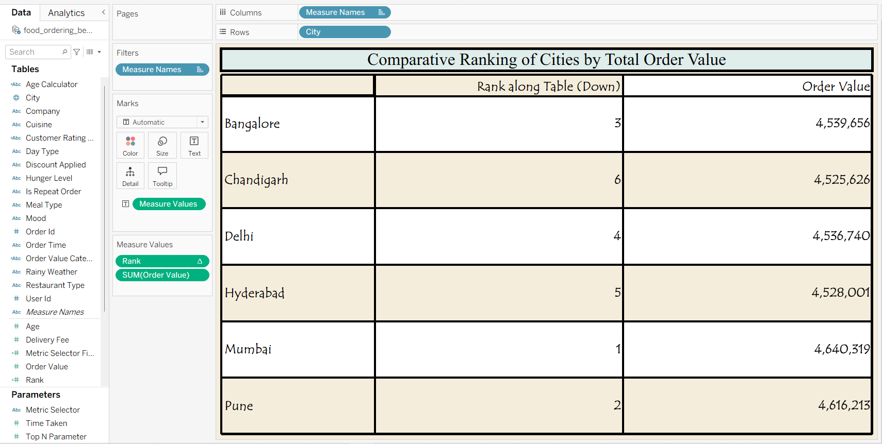
Q8. How are total orders distributed across cities?
- Visualization: Donut chart showing count of orders by city.
- Insight Provided: Order counts are nearly evenly split across all six cities, each holding roughly 16–17% share. Unlike order value, which shows more spread between top and bottom cities, order volume is uniform — implying revenue differences are driven more by order size/pricing than by how many people are ordering in each city.
- Screenshot of visualization:
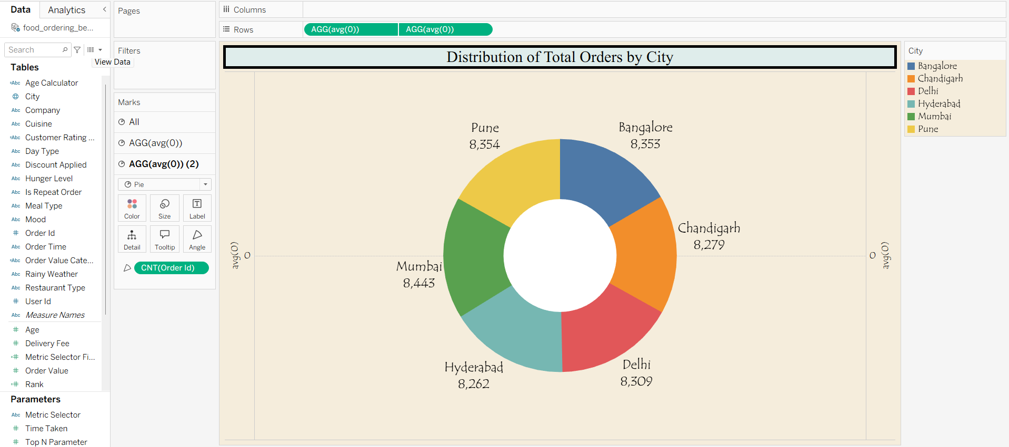

Q9. Does dining companionship type affect customer satisfaction ratings?
- Visualization: Stacked bar chart showing count of orders by company type, broken down by customer rating category.
- Insight Provided: Poor Service is the largest rating segment across all four companionship types, but the Poor-to-Excellent ratio is worst for Partner orders (5,139: 884, ~5.8:1) and best for Family orders (4,906: 922, ~5.3:1). While the difference is modest, it suggests orders placed for two people may receive slightly less careful handling than larger family orders — worth validating against delivery time or order accuracy data before drawing firm conclusions.
- Screenshot of visualization:
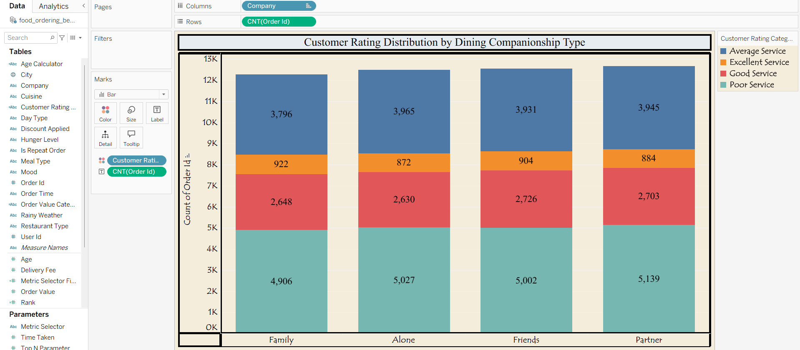

Q10. Does repeat order rate vary by generation?
- Visualization: Bar chart with reference line showing average repeating-order rate by generation (Gen Z, Young Millennials, Older Millennials).
- Insight Provided: Repeat order rate stays close to the 0.4960 average across all three generations, with no cohort significantly over- or under-performing. This indicates loyalty and retention drivers (app usability, delivery reliability, discounts) resonate similarly across age groups, so retention strategies likely don't need heavy generational segmentation.
- Screenshot of visualization:
